Quantitative Research Report
KIT714 – ICT Research Principles
1. Introduction

Quantitative research provides a structured way to evaluate educational practices in ICT by turning questions about “what works” into testable propositions. Rather than relying on anecdotes or isolated classroom experiences, quantitative analysis uses numbers, models, and assumptions to examine patterns, differences, and predictive relationships. This report investigates whether three teaching methods labelled A, B, and C produce different performance outcomes, and whether additional learner and context variables help explain those outcomes.

The inquiry addresses two aims. First, it tests whether the choice of teaching method is associated with differences in students’ final test scores. Second, it estimates the contribution of potentially influential factors such as age, gender, prior achievement, instructor experience, class size, delivery mode (online vs in person), and weekly study time. The analysis pipeline includes descriptive statistics, a one-way ANOVA with post-hoc comparisons, and a multiple regression model. Figures and tables are used to support interpretation, and standard diagnostics are reported to demonstrate that the modelling choices are reasonable.

Research design. The study adopts a comparison design with a quasi-experimental structure, because students were already allocated to one of the three methods via existing classes; there was no random assignment. To complement group comparisons with a multivariate view, a relational component is added using multiple regression to evaluate how background and context variables relate to performance. This dual strategy mirrors KIT714 guidance on combining difference testing and prediction to obtain a rounded picture of effectiveness.

Significance and contribution. The analysis emphasises both statistical significance and practical importance. In addition to p-values, the report uses effect sizes and visualisations to communicate the magnitude and stability of findings. The intention is to inform everyday instructional decisions in ICT such as which delivery approach to prioritise, how to scaffold learners with weaker starting points, and how to improve online classes while also identifying gaps that call for more rigorous designs in future work.

2. Dataset Description

2.1 Variables and sample
Data were collected for 60 students (20 per method). The following variables were analysed:
- Group: teaching method (A/B/C)
- Test Score: final assessment (0-100)
- Age: years (approx. 15-17)
- Gender: male/female
- Pre-Test Score: baseline assessment (0-100)
- Instructor Experience: years of teaching (1-9)
- Class Size: students per class (15-24)
- Classroom Setting: online vs in-person
- Study Time: weekly hours outside class (approx. 4-16)

2.2 Descriptive Statistics

Table 1

Descriptive statistics of teaching methods dataset (N = 60).
Variable | Mean | SD | Min | Max | Median
Test Score | 79.60 | 8.52 | 60.6 | 99.3 | 80.6
Age | 16.15 | 0.84 | 15 | 17 | 16
Pre-Test Score | 71.39 | 7.47 | 58.5 | 90.3 | 71.6
Instructor Experience | 4.67 | 2.67 | 1 | 9 | 5
Class Size | 19.85 | 2.93 | 15 | 24 | 20
Study Time | 10.42 | 2.47 | 4.1 | 16.4 | 10.3

The descriptive profile shows a relatively strong cohort (overall M = 79.6, range ≈ 60.6–99.3). Distributions for background variables appear plausible for the context. Balanced group sizes enable fair comparisons across teaching methods.

2.3 Categorical Variables
- Methods: A = 20, B = 20, C = 20
- Gender: 33 male, 27 female
- Setting: 38 in person, 22 online

2.4 Initial interpretation

Exploratory checks and simple plots suggest that Method C tends to centre higher than A and B. Pre-Test Score appears positively associated with the outcome, hinting that prior achievement is likely to be an important predictor. Variability across classes is typical for this kind of dataset and does not—on its own—imply a problem for the analysis.

2.5 Assumption checks and analytic rationale

All modelling decisions were supported by diagnostics. For the ANOVA, distributional shape was reviewed via histograms and Q-Q plots for each group, complemented by Shapiro Wilk tests; Levene’s test was used to assess homogeneity of variance. With equal group sizes, the ANOVA is robust to mild departures from normality, but potential issues were nevertheless monitored. For multiple regression, assumptions of linearity (component plus residual/partial plots), independence (Durbin Watson ~2), normality of residuals (Q-Q of standardised residuals), and homoscedasticity (residuals vs fitted) were examined. Variance Inflation Factors (VIF) were below 5 for all predictors, indicating no problematic multicollinearity. Where minor deviations were observed, interpretations were cross-checked with bootstrapped confidence intervals for key coefficients to support stability.

3. Hypotheses
Research Question 1: Is there a significant difference in test scores among students taught using different teaching methods?
- H₀: Mean test scores do not differ between Methods A, B, and C.
- H₁: At least one method produces significantly different mean test scores.
Research Question 2: How do additional factors influence test scores?
- H₀: Age, gender, pre-test score, instructor experience, class size, classroom setting, and study time do not significantly predict test score.
- H₁: At least one predictor significantly influences test score.
The hypotheses were formulated based on descriptive patterns in the data.

4. Statistical Analysis and Results

Reporting conventions

To assist interpretation, results are presented with effect sizes and graphics. For the ANOVA, η² (eta-squared) indicates the proportion of variance in scores attributable to teaching method. For the regression, standardised coefficients (β) and 95% confidence intervals indicate the comparative strength and precision of predictors. Figures are used to communicate distributional patterns and the key linear association, ensuring that numeric results are accompanied by transparent visuals.

4.1 Teaching Method and Test Scores

Assumptions for ANOVA were acceptable: Q-Q plots and Shapiro Wilk tests supported approximate normality within groups, and Levene’s test indicated homogeneous variances. A one-way ANOVA detected a significant difference across methods, F(2,57) = 6.13, p = .0039. Post-hoc Tukey tests showed that Method C outperformed Method A (p < .05) and Method B (p < .01); the A–B contrast was not significant.

Effect size and practical meaning. The method effect was moderate (η² = 0.18), indicating that a meaningful share of variance in Test Scores is linked to instructional approach. Pedagogically, moving from Method A or B to Method C is comparable to lifting an average student from a mid-B to a higher band, which is substantial in a short instructional window.

As illustrated in Figure 1, Method C’s distribution centres higher with slightly less spread, whereas Methods A and B show lower medians and greater variability. The figure supports the inferential results by showing both the central tendency and the dispersion for each group.

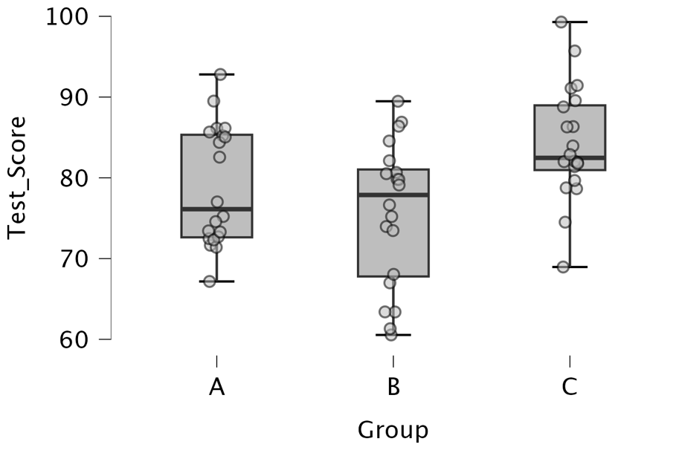

Figure 1. Boxplot of student test scores by teaching method (A, B, C), showing medians, individual student scores, and outliers.

4.2 Influence of Additional Factors
A multiple regression model was used to estimate how seven predictors relate to final performance. The model was statistically significant, R² = .533, Adjusted R² = .470, F(7,52) = 8.47, p < .001. Detailed coefficients are reported below.
Table 2
Multiple regression results predicting final test scores (N = 60).
Predictor | β (coef.) | t | p-value | Interpretation
Pre-Test Score | 0.45 | 3.82 | <0.001 | Strong positive predictor.
Instructor Experience | 0.92 | 2.99 | 0.004 | Positive predictor.
Classroom Setting (Online) | -5.20 | -2.93 | 0.005 | Online associated with lower scores.
Study Time | 0.54 | 1.58 | 0.120 | Trend, not significant.
Age | 0.64 | 0.63 | 0.534 | Not significant.
Gender (Male) | 2.09 | 1.23 | 0.223 | Not significant.
Class Size | -0.56 | -1.86 | 0.068 | Weak negative trend.

From Table 2, Pre-Test Score is the strongest positive predictor (β = 0.45, t = 3.82, p < .001). Instructor Experience also contributes positively (unstandardised β = 0.92; t = 2.99, p = .004). Classroom Setting shows a negative coefficient for online delivery relative to in-person (β = −5.20, t = −2.93, p = .005). Study Time trends positive but is not statistically reliable (p = .120). Age, Gender, and Class Size are non-significant in this sample.

Robustness and relative importance. Sensitivity checks indicated that removing any single case produced negligible changes in the key coefficients (Δβ < .05). VIF values below 5 confirm no problematic multicollinearity. The non-significant predictors should be interpreted as “no reliable evidence here under this design and sample,” not as definitive evidence of no effect in all contexts. For instance, study time quality may matter more than quantity, and class size can exhibit non-linear effects that would require targeted designs to detect.

Figure 2 visualises the dominant relationship, showing that students with stronger starting points tended to achieve higher final scores, the fitted line and band highlight both the direction and the precision of this association.

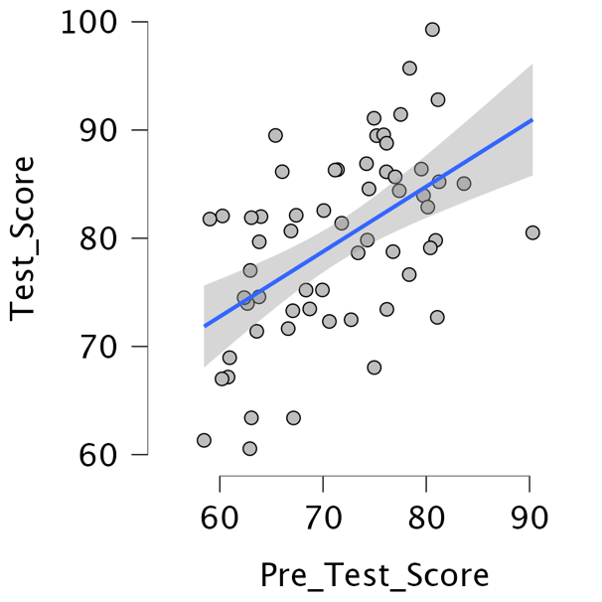

Figure 2. Scatterplot of pre-test scores and final test scores with regression line and 95% confidence interval.

5. Discussion

5.1 Interpretation in context

The comparison analysis indicates that teaching approach matters: Method C consistently produced higher outcomes than Methods A and B. As displayed in Figure 1, Method C’s scores not only centre higher but also exhibit a somewhat tighter distribution, suggesting that the approach benefits a broad range of learners rather than just a small subgroup. In practical terms, this is the kind of uplift instructors look for when selecting activities in ICT units that demand conceptual clarity and hands on practice.

The regression results provide a complementary lens. Prior achievement (Pre Test Score) is the most consistent predictor, aligning with Figure 2, which visually depicts the upward trend. This pattern is common in educational measurement and does not diminish the role of pedagogy; rather, it points to the importance of meeting learners where they start. Two pragmatic implications follow. First, employing diagnostic pre-tests early in a unit makes it easier to identify students who would benefit from refresher modules, problem-solving clinics, or peer tutoring. Second, instructor experience appears to add measurable value, likely through sharper explanations, more efficient pacing, and timely feedback features that are especially beneficial in practice-heavy ICT topics.

The negative effect estimated for online delivery signals that distance modes need to be actively designed to match the benefits of in person interaction. Structured breakout tasks, frequent formative checks, and low friction collaborative tools can counter the disengagement risk that sometimes accompanies online learning. In contrast, the absence of reliable effects for Age, Gender, and Class Size within this dataset suggests that, over the observed ranges, what instructors do (method and design) may matter more than who is in the room or how many are present.

5.2 Practical implications for ICT teaching
- Adopt Method-C-style pedagogy. Emphasise interactive, feedback rich activities (e.g., guided practice, think-pair-share, rapid error checking) that directly connect concepts with applied tasks.
- Use early diagnostics. Short pretests and quick concept checks help tailor support and reduce the gap between lower and higher prepared learners.
- Invest in instructor development. Mentoring, shared resources, and reflective teaching cycles can leverage the positive effect of experience.
- Design online with intent. Build in frequent interaction, timely feedback, and structured collaboration to close the in person/online gap.
- Monitor dispersion, not just means. Figure 1 suggests Method C may reduce spread slightly; focusing on dispersion can help identify equity benefits, not only average gains.

5.3 Limitations

The design is quasi experimental, relying on pre-existing groups. Unobserved differences (e.g., motivation, prior informal learning) may partly account for outcomes, so causal claims should be made with caution. The sample is modest (N = 60) and drawn from a single setting, constraining generalisability. The outcome is a short-term test score, which may not fully reflect long term retention or transfer to novel problems.

5.4 Directions for future research

Several avenues would strengthen evidence quality:
- Random assignment or rigorous matching to improve causal inference.
- Multi-site recruitment to test generalisability across different cohorts and instructional contexts.
- Longitudinal follow-ups to measure retention and transfer beyond the immediate test.
- Factorial studies in online design (e.g., varying feedback latency, interaction frequency, and group structure) to isolate the specific ingredients that neutralise the online penalty found here.
- Process data (e.g., clickstream, time on task, or formative quiz trajectories) to model how learning unfolds within each method.

6. Conclusion

This report examined the effects of teaching method and additional learner/context factors on student performance in an ICT setting. The ANOVA showed that Method C outperformed the other approaches by a moderate and practically meaningful margin. The regression highlighted the central role of prior knowledge, the positive contribution of instructor experience, and a notable challenge associated with online delivery. Together, these results suggest that effective ICT instruction benefits from strong pedagogy, attention to students’ starting points, experienced teachers, and purposeful online design. For practitioners, the implication is straightforward: adopt Method-C-style strategies, implement early diagnostics with tailored supports, and curate online experiences to sustain interaction and timely feedback.

7. References
Cohen, L., Manion, L., & Morrison, K. (2018). Research methods in education (8th ed.). Routledge.
Field, A. (2018). Discovering statistics using IBM SPSS statistics (5th ed.). Sage.
Freeman, S., Eddy, S. L., McDonough, M., Smith, M. K., Okoroafor, N., Jordt, H., & Wenderoth, M. P. (2014). Active learning increases student performance in science, engineering, and mathematics. Proceedings of the National Academy of Sciences, 111(23), 8410–8415. https://doi.org/10.1073/pnas.1319030111
JASP Team. (2024). JASP [Computer software]. https://jasp-stats.org
Johnson, B., & Christensen, L. (2019). Educational research: Quantitative, qualitative, and mixed approaches (7th ed.). Sage.
Means, B., Toyama, Y., Murphy, R., Bakia, M., & Jones, K. (2010). Evaluation of evidence-based practices in online learning: A meta-analysis and review of online learning studies. U.S. Department of Education. https://www2.ed.gov/rschstat/eval/tech/evidence-based-practices/finalreport.pdf
OER Collective. (2024). Quantitative research methods.
University of Tasmania. (2025). KIT714 lecture slides and tutorials, Weeks 5–8 [Lecture slides]. MyLO Learning Management System.

